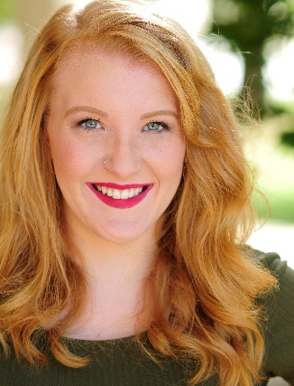
Cassandra Lampen

(913) 426-0650 Cassandra.lampen.14@gmail.com Cassandralampen.com

Height: 5’7” Hair: Strawberry Blonde Eyes: Green

Film and Television
Look- City of Union Music Video Marisa (Supporting) Collin Cook
Springfield Police Dept. Commercial Student (Supporting) David Cron
The Meeting Woman (Lead) Missouri State University
The Yellow Wallpaper Wife (Lead) 1893 Productions
Tough Love Woman (Lead) Missouri State University
Establishing Obscurity Nadine (Lead) Evangel University Films

Professional Theatre
Peter and Wendy Smee Missoula Children’s Theatre

Theatre
Hand Grenades Diana Tabula Rasa
In-School Players Troupe Manager Missouri State University
A Study of the Subconscious Medium Tabula Rasa
The Dutchman Train Car Rider Missouri State University
Cheaper by the Dozen Anne Gilbreth Charger Theatre
Fiddler on the Roof Tzeitel Charger Theatre
You Can’t Take It With You Penny Charger Theatre
Glass Menagerie Laura Wingfield Charger Theatre

Scene Study
Ivanov Sasha Missouri State University
Closer Anna Missouri State University
The Normal Heart Emma Missouri State University
The Shape of Things Jenny Missouri State University

Training
BFA Acting (2018) Missouri State University
Acting (Meisner, Stanisklavski) Robert Westenberg, Lisa Brescia, Kurt Heinlein, Sarah Wiggin,
Camera Kurt Heinlein
Shakespeare Lisa Brescia, Sarah Wiggin
Movement (Linklater, Alexander) Melanie Dreyer-Lude, Chris Brown, Lisa Brescia
Dialects Robert Westenburg
Stage Combat Kurt Heinlein

Special Skills
Western (Some English) Horseback Riding, Biking, Roller Skating, 8 Years Clarinet Training, Swimming, Computer Literate, Childcare Experience, Animal Friendly, Directing, CPR-First Aide Certified, Class C Kansas Driver’s License, Passport, Skydiving Experience, Backpacking, Face Painting, Balloon Twisting, Fitting an Entire Set and Costumes in the Back of a Ford F-150, Barista Experience

